EXPERIMENT NO.8

Student Counselling System using Zoho Creator (SaaS)

AIM
To develop a cloud-based Student Counselling System using Zoho Creator for managing student counselling details.
INPUT AND OUTPUT
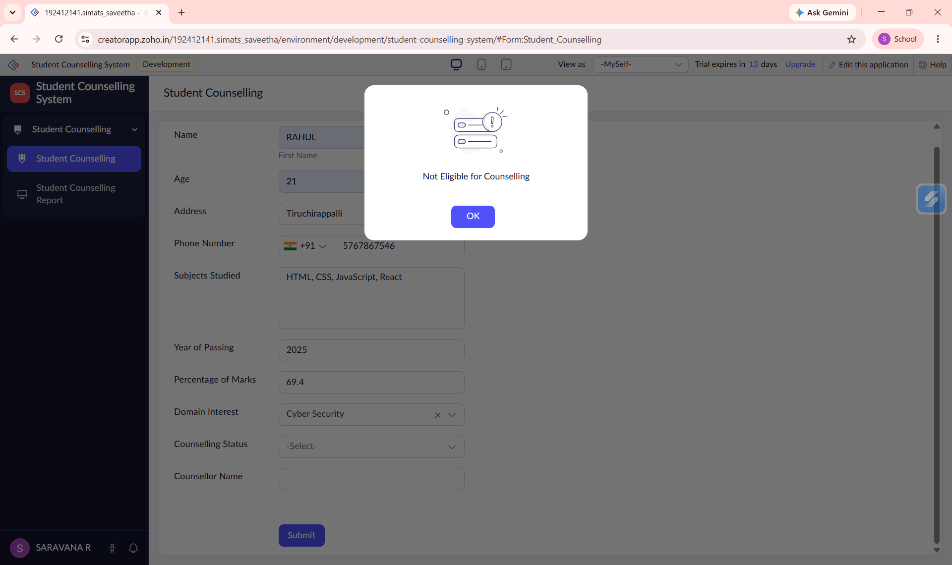
Figure 1: Eligibility Alert
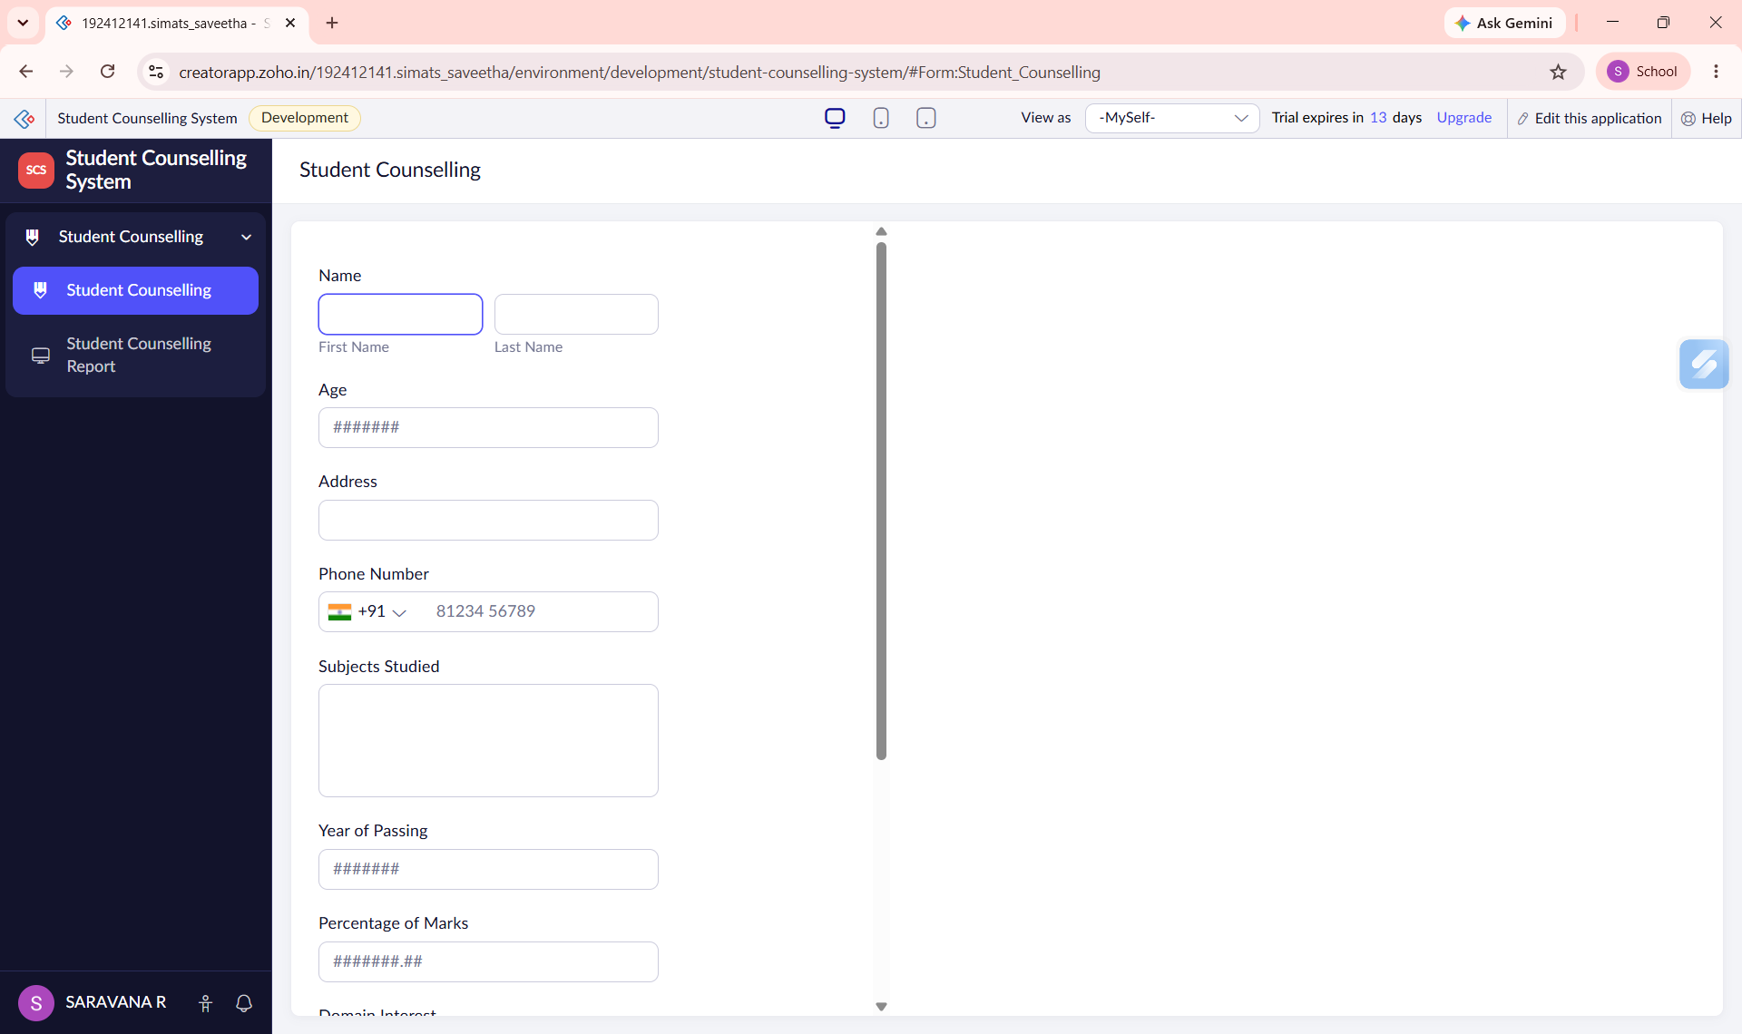
Figure 2: Student Counselling Form
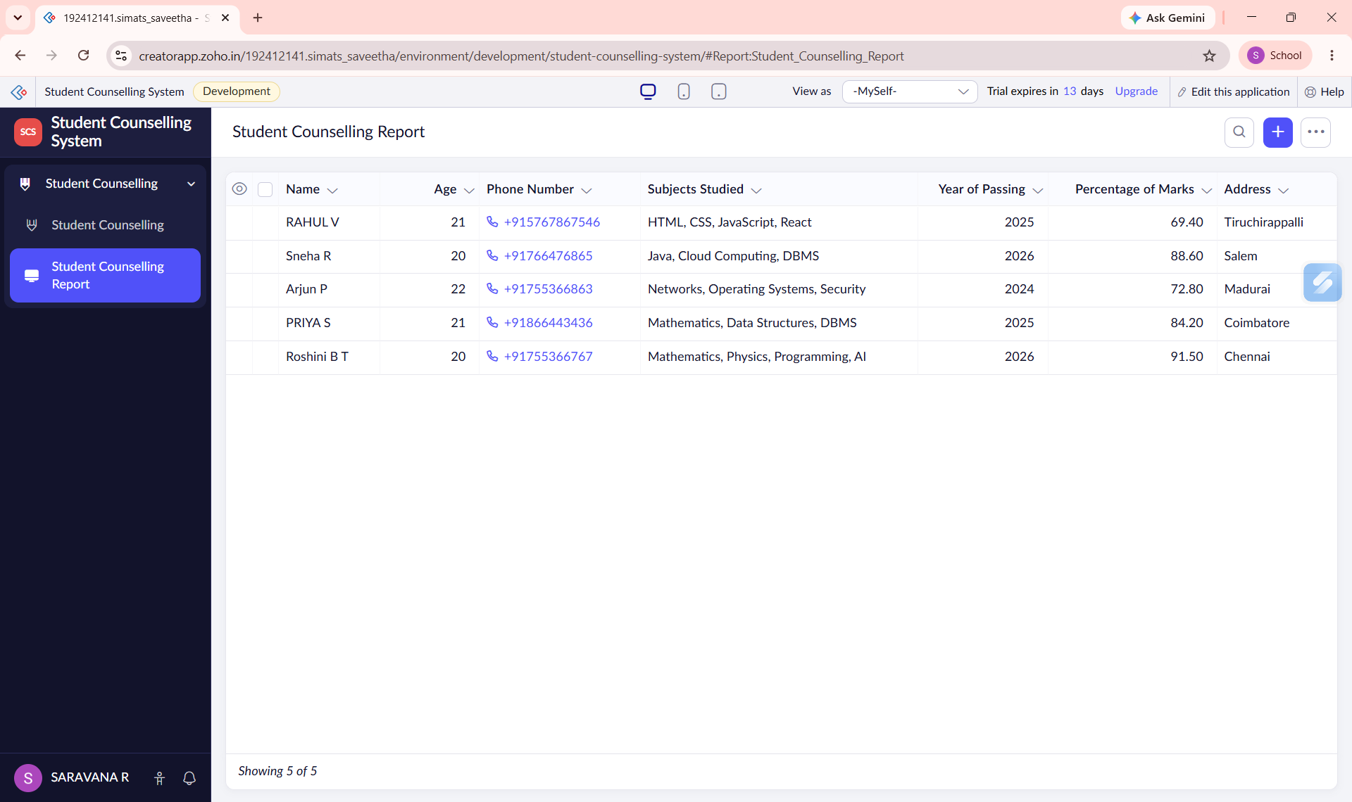
Figure 3: Student Counselling Report
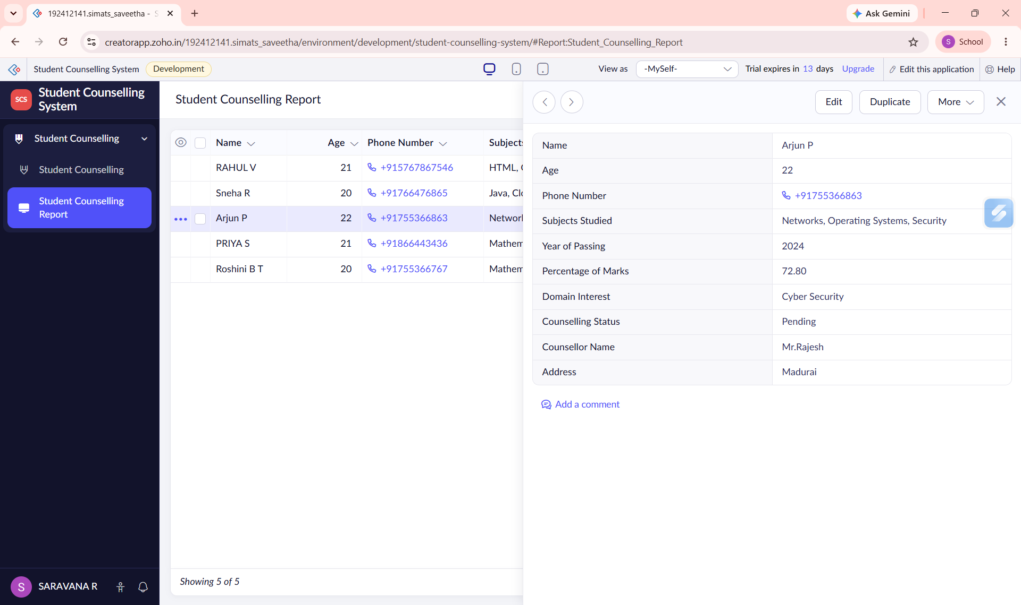
Figure 4: Individual Record View

Result
The Student Counselling System was successfully developed using Zoho Creator.

